## MAPPING OF RELEVANT BENCHMARKS

### Identification

#### 6th of October Dry Port - Egypt

The 6th of October Market was established in accordance with the 6th of October Market decree stating the internal regulation of the market and its operational sanction regulation and was placed under the authority of the Giza Governorate. The construction of the 6th of October Market began in May 1992 and was completed in June 1996. Its effective operation began in February 1998. The total area of 6th of October Market is 135 feddans including 42 buildings.

The market’s objectives according to the 6th of October Market decree is to carry out the wholesale of vegetables, fruits and poultry to be provided to the Giza Governorate and the neighbouring governorates at reasonable prices, as well as working on displaying and preserving these products in practical and modern ways. Furthermore, the 6th of October Market is looking to benefit from the surplus of the supplies by storing, manufacturing or packaging it and offering it to the public at appropriate times throughout the year in order to prevent any shortage or price surge.

In July 2021, the EBRD has provided a senior loan of up to USD 29.6 million (EUR 25 million) in favour of October Dry Port Company as part of a total investment package of USD 60 million to finance the design, development, construction and operation and maintenance of the 6th of October Dry Port ("DP6"), the first in land dry port in Egypt in the city of 6th of October, west of Cairo.

The development and construction of the 6th of October Dry Port is the first public-private partnership (PPP) project in the sector in Egypt. As Egypt’s first inland dry port, DP6 will function as an extended gateway to the deep sea ports located in the northern and eastern regions of the country, thus supporting the existing port infrastructure and logistics market and pushing forward the green agenda by encouraging a modal shift from road to rail. DP6 will be the final destination of the cargoes and will (i) provide efficient customs inspections and clearance procedures, (ii) reduce congestion in the seaports, (iii) create economies of scale by using intermodal rail services to/from the seaports and (iv) improve the overall reliability and cost-efficiency of the logistics processes of the dry port's future clients. Additionally, the Project is also expected to transfer part of the container traffic from road to railway, thus realising many social, environmental and economic benefits such as reduced road congestion, accidents and environmental emissions.[1]

In April 2022, DP6 won the award of IJ Global Transport Deal of the year for the MENA region.

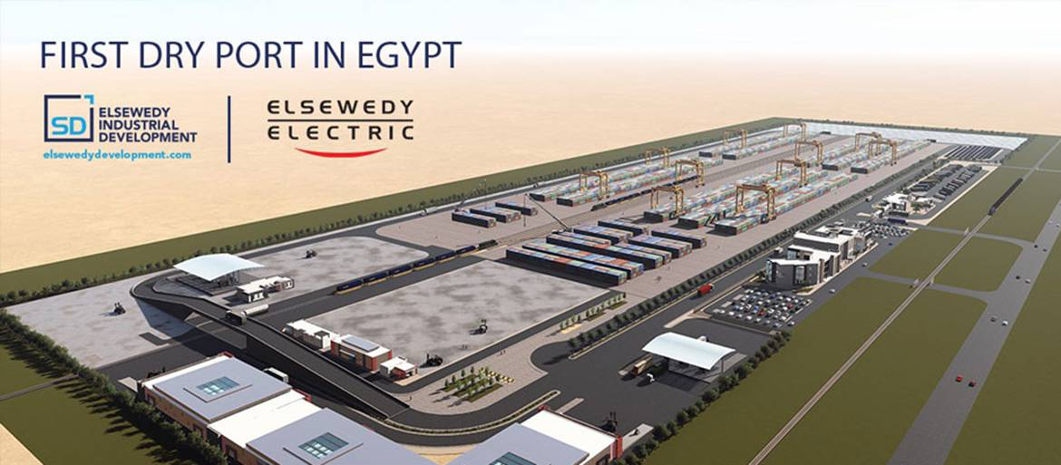

Figure 2 Overview of the 6th of October Dry Port Project

*Source: SID - https://www.elsewedyelectric.com/en/news-room/sid-to-build-the-first-dry-port-in-egypt/*

#### The Rungis International Market – France

Inaugurated on March 3, 1969, The Rungis International Market (Marché d'Intérêt National de Rungis - MIN[2]) is the principal food market of Paris serving the Paris metropolitan area and beyond, mainly for food and horticultural products, located in the commune of Rungis and covering three municipalities (Rungis, Thiais, Chevilly-Larue) in the southern suburbs. Today, Rungis International Market is the second largest wholesale food market in the world covering 234 hectares (550 000 m2), behind La Central de Abastos, located in Mexico City with 327 ha. However, it is considered as the world's biggest fresh produce market in the world.

Rungis Market trades an exceptional variety of food products, the majority of which is fresh produce, as well as flowers, plants and decorations. The market is host to more than 1200 companies and welcomes more than 18 million customers annually. Every day, 9,500 tonnes of goods pass through it for an annual turnover of € 9 billion. [3]

Figure 3 Overview of Rungis International Market

*© Semmaris*

The market is the property of the French State and administered by the Joint Venture Semmaris (*Société d'Economie Mixte d'Aménagement et de gestion du marché d'intérêt national de Rungis*). In 2015, the State chose to extend the mission entrusted to SEMMARIS to develop and operate the Rungis site until December 31, 2049. More than one billion euros will be invested over 10 years by Sammaris, which will result in 230,000 m2 of new or completely restructured buildings.

Arrivals on the market fall into four predominant sectors:

* the fruit and vegetable sector, the first sector of activity of the market with its 870,000 tonnages marketed, i.e. approximately 55% of arrivals,
* the meat products sector (300,000 tonnage, 21% of the total),
* the dairy products sector (175,000 tonnage, 12%),
* the seafood industry (170,000 tonnage, 11.5%).[4]

For these four sectors of activity, different types of operators are involved, whose weight in the supply varies according to the sector, although trends are to be noted. All sectors combined, the vast majority of companies operating in the market are wholesalers. At the same time, other operators also participate in sales, in varying proportions, such as brokers and import/export companies, producers and finally central purchasing bodies.

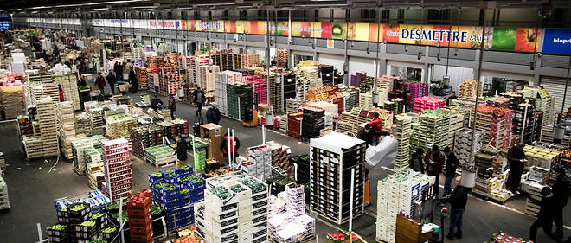

Figure 4 Interior view of the fruit and vegetable pavilion of Rungis

*© MaxPPP/Vincent Isore*

The successful Rungis model is an international benchmark that is intended to be exported or even duplicated by a number of countries such as Vietnam, the Philippines, Benin, Hungary and UK.

A new concept for creating wholesale markets under the “Rungis” license has just been initiated in Dubai and will be rolled out with other partners. It includes in particular the feasibility and design of the project, assistance with the realization and operation with brand and software licenses.

In early 2022, Semmaris has signed a partnership agreement with the GAG Ghassan Aboud Group and the KIZAD Abu Dhabi Port Authorities in order to support the creation of the future agro-logistics hub of Abu Dhabi. The signing and official launch of this project took place in the Kizad logistics area, located halfway between Abu Dhabi and Dubai, in the presence of the project’s sponsors and the highest Emirati authorities. This public-private partnership project will benefit from the expertise of Semmaris in the fresh produce sector and agro-logistics infrastructures.

Three years ago, Semmaris had started negotiating with the GAG Ghassan Aboud Group, one of the largest conglomerates in the Middle East, and with the KIZAD Abu Dhabi Port Authorities, a group of Abu Dhabi’s sovereign wealth fund, on this project aiming at storing food products and deploying a logistic and digital capacity on a regional scale (Emirates, Bahrain, Qatar, Kuwait, Oman).[5]

#### The date market (the oasis of palm trees) in Medina – Saudi Arabia

The palm oasis project site is a 100-hectare piece of land located near the King Khaled Highway at the northeast corner of the Alhejra intersection in Medina, Saudi Arabia. It is located 14.5 km southwest of the Prophet's Mosque.

The project aims to provide Saudi Arabia with an international hub with a date market that functions as a trading center. The project will be integrated with facilities offering different types of services around the date industry. It comprises 8 components namely a hotel, a retail space, a storage space, packaging and manufacturing facilities, an exhibition area, a research and development laboratory and a museum.

The total investment is estimated at 518.7 million Riyals (77 billion FCFA). Around 40% of the project's estimated revenue should be generated by the hotel and 30% by the rental of retail space.

The selected PPP arrangement puts the project company ''Palm Oasis Company'' at the heart of the coordination process between the various public stakeholders including the municipality and private parties including the promoter, the operator and the banks.

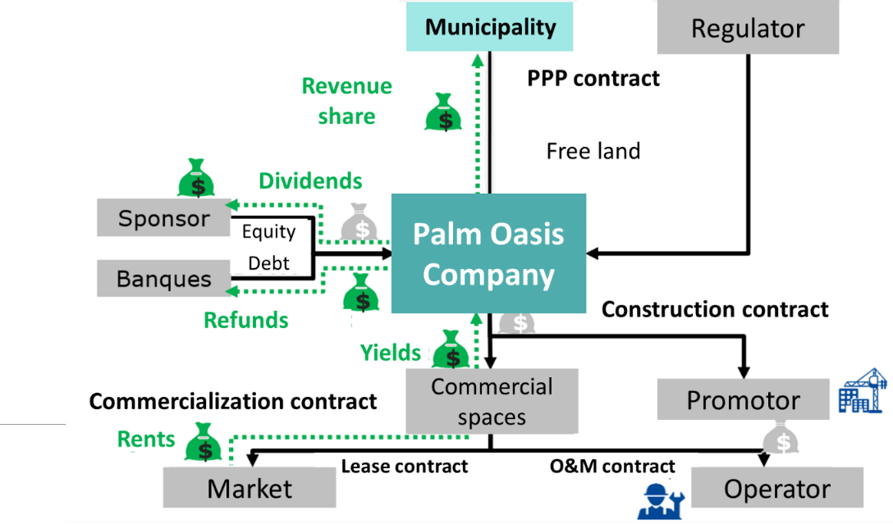

Figure 6 Project of the oasis of dates – PPP arrangement

1. EBRD finances 6th of October Dry Port in Egypt under EBRD Green Cities: https://www.ebrd.com/news/2021/ebrd-finances-6th-of-october-dry-port-in-egypt-under-ebrd-green-cities-.html
2. A market of national interest (Marché d'Intérêt National - MIN) in France is a wholesale market reserved for professional operators (producers, importers, restaurateurs, wholesalers and retail traders). MINs offer collective sales management services for agricultural, food and horticultural products. The establishment of wholesalers and producers, within the MIN or within the reference perimeter that surrounds it, is regulated and must be authorized. *(service-public.fr)*
3. https://www.rungisinternational.com/en/
4. The economic model of the Rungis MIN and its development prospects: https://www.institutparisregion.fr/fileadmin/NewEtudes/Etude_1098/Le_modele_economique_du_MIN_de_Rungis_et_ses_perspectives_d_evolution.pdf
5. https://www.freshplaza.com/article/9398968/france-rungis-market-signs-a-strategic-partnership-agreement-for-the-creation-of-an-agro-logistics-hub-in-abu-dhabi/